**Project Design Phase-II**

**Data Flow Diagram & User Stories**

|  |  |
| --- | --- |
| Date | 11 October 2022 |
| Team ID | PNT2022TMID11929 |
| Project Name | News Tracker Application |
| Maximum Marks | 4 Marks |

**Example:**

**Flow**

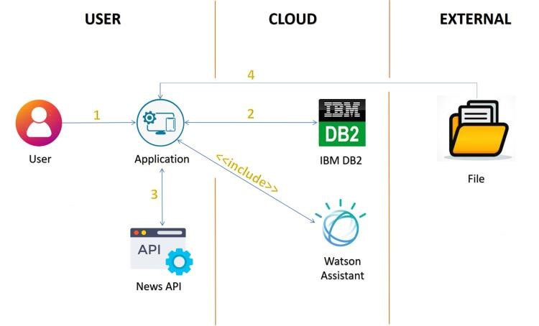

**DFD(level 0)**

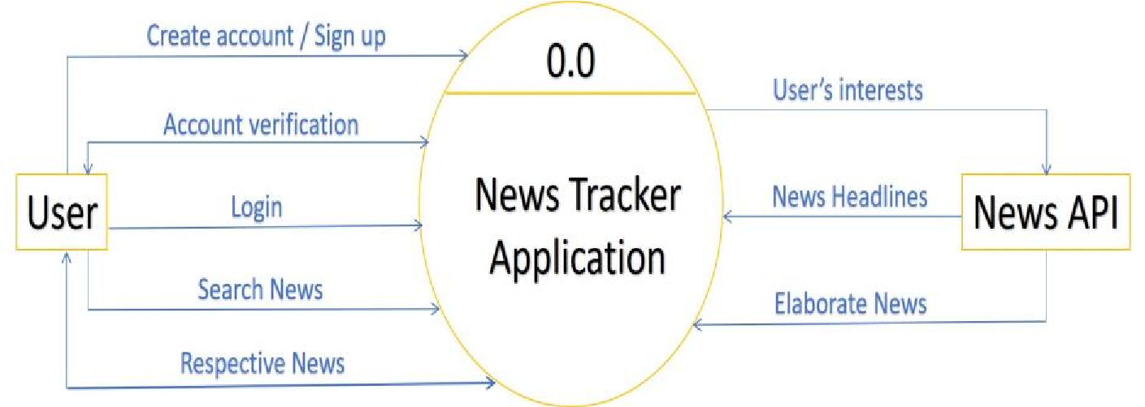

1. User log in to the application
2. Validate user details with the records in the ibm db
3. News api gives the headlines after login
4. User click the headlines to get the whole news
5. User can download the news to read it in offline mode
6. Watson assistant is used to clear doubts if needed

**User Stories**

|  |  |  |  |  |  |  |
| --- | --- | --- | --- | --- | --- | --- |
| **User Type** | **Functional**  **Requirement (Epic)** | **User Story Number** | **User Story / Task** | **Acceptance criteria** | **Priority** | **Release** |
| Customer (Web user) | Registration | USN-1 | As a user, I can register for the application by entering my email, password, and confirming my password. | I can access my account / dashboard | High | Sprint-1 |
|  |  | USN-2 | As a user, I will receive confirmation email once I have registered for the application | I can receive confirmation email & click confirm | High | Sprint-1 |
|  | Login | USN-3 | As a user, I can log into the application by entering email & password | I can access my dashboard | High | Sprint-2 |
|  | Home Page | USN-4 | As a user I can view the headlines of the news that interest me | I can read the news elaborately by clicking on the headlines | High | Sprint-2 |
|  |  | USN-5 | As a user I can view the elaborate content of the headlines | I can download that to read it when iam free even in offine mode | Medium | Sprint-3 |
|  |  | USN-6 | As a user I can search a news I want | I can read the news elaborately | High | Sprint-4 |
| Customer Care Executive | Chatbot | USN-6 | As a user I can solve my doubts about the application with the help of the chatbot.If the doubt is not resolved the chatbot guides us on how to contact the customer care executive | I can contact the customer care executive if needed | Medium | Sprint-3 |
| Administrator | About us | USN-7 | As a user I can view about the application and the developers of the application | I can be able to see their other applications | low | Sprint-4 |